Created by Lionel Weber, the 11 May2011
Modified by Lionel Weber, the 15 May 2013

Wigii Email external access concepts
(or public access through a unique and secure link)

Background:
When a subscription is done in the Wigii system, the element could contain an Email field. This email field should be validated following the double opt in process. Once the email validated the email owner could want to update his information or delete them. The Email external access concepts is to solve this purpose. Here are the nice side effects:
- an element containing an Email field could be viewed externally or updated only by granting external access on an item to the email of the item, and this even outside of a subscription process.

Emails datatype
The Emails datatype is updated with 3 more subfields to handle the external access:
- externalConfigGroup (int of an idGroup which we will use the config)
- externalAccessLevel (tinyInt, 0= no access, 1= read access, 2= write access, const defined in datatype class Emails)
- externalCode (sha1(str2lower(CLIENT_NAME-timestamp-rand-fieldName-value)))
- externalAccessEndDate (int representing a timestamp limiting the access to a certain date. If null → unlimited)

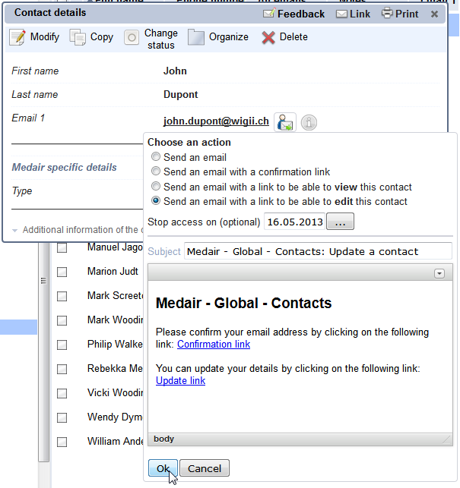
This email will send a link to john.dupont@wigii.ch valid until the 16.05.2013. If John follows this link before this date, he will be able to edit his contact details. Be aware that you can use the attributes: readonlyInPublic, onlyInPublic, notInPublic, requireInPublic to control which fields John can see from the external access. Those attributes are followed as well in the subscription process.

Process

An attribute maxExternalAccessLevel can be defined in an Email field config. This will stop the possibility to upgrade the externalAccessLevel. This attribute is only checked in the menu process.

The ConfigGroup is defined when the external access is given. This subfield contains the group id of the current group selected when the enabling of the externalAccess is provided. This action is to maintain the same view for the user accessing externally. So be carefull in a multiple configuration environment to enable external access while having the correct group selected.

The WigiiExecutor handles a new entry point in the element section: element/elementId/manageEmail

The externalAccessCode is unique and random. Each change of the email value reset the externalCode and → all the external links

In the DetailElementFormExecutor.php the email menu is displayed using the TemplateRecordManager with the subfield externalCode.

The externalAccess case in the WigiiExecutor handles: view, edit, delete, or unlock

The externalAccess and the subscriptions
When subscriptions parameters are define within a group you can control the externalAccess by adding an Access link in the confirmation email.
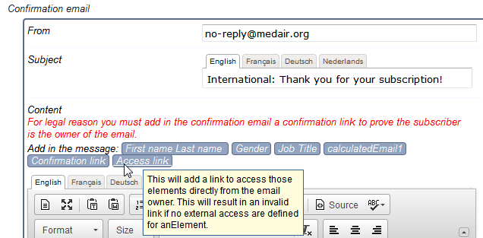

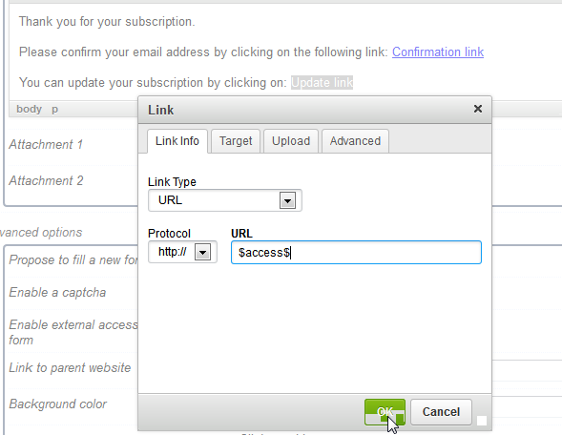
If a $access$ is detected in the confirmaiton email, then the new subscription email field (the first email field, or the first one with attribute enableForEmailing=1) will automatically be filled with externalAccessLevel=2, externalConfigGroup=current folder id for which the subscription parameters applies, externalAccessEndDate=the end date of the subscription timeframe if defined.

Note : the externalAccess feature can only be available in the subscription parameters if an email field is part of the configuration.

In the Advanced option you can “Enable external access request form” 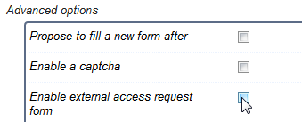

By ticking this checkbox, the folder details will provide a special link that you can share or publish on a website in order to let people resubmit their email address to receive the external access link by email. I.E.:

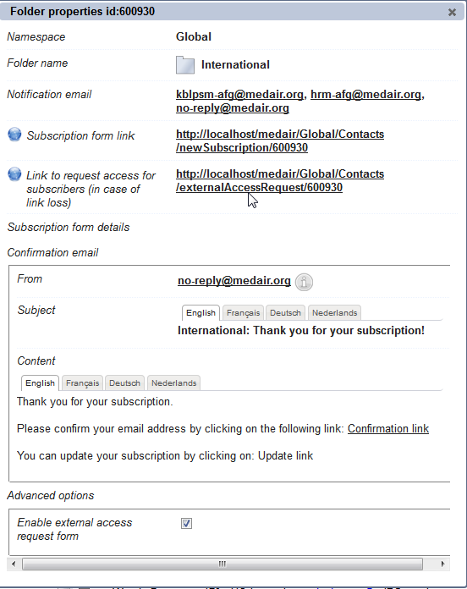

The Link to request access for subscribers brings on a small form: 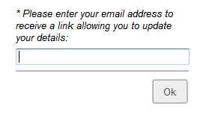
The goal here is in case the subscriber has lost his confirmation email with the update link, he can request again an access link to update his details.

Note: You can use this feature on an existing folder containing contacts. By doing that, it enables you the possibility to share this link to let your contacts requesting themselves the ability to update their details in your database.

The ExternalAccess and the Emailing
You can use the ExternalAccess and the Emailing feature in order to send an email to your contacts and inviting them to update their detail from a link embedded in the email.

First select a few contacts:
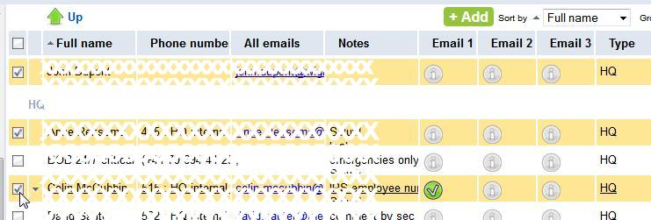

Then click on External access :
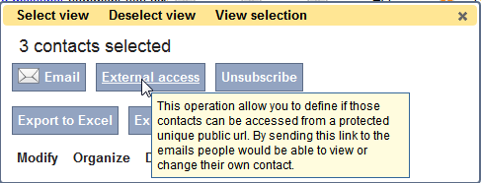

Choose « Enable external access (read / write)
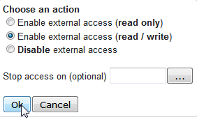

Once this is done, each selected contacts have their email field set with:
externalAccessLevel=2, externalConfigGroup=current folder id, externalAccessEndDate=the date you might have defined in “Stop access on”

Let’s see now how to communicate to those contacts the link with which there will be able to edit their own detail:
Click on Email
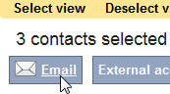

Type in the email message :
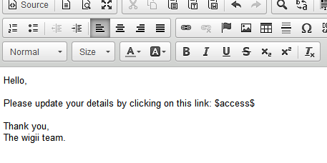
The Email service will detect the presence of $access$ and will process the correct link for each selected contact. This is coded in EmailingFormExecutor.php in the method processRecipients. This method use the Email merge feature and will replace the $access$ with the external access links.

Note: in the method EmailingFormExecutor->doSpecificCheck the system checks that each contacts has external access enabled (if there is $access$ defined in the email body).

